
AACS2303 INTRODUCTION TO INTERFACE DESIGN
ASSIGNMENT REPORT

Programme : DFT1S3 (Intake: 202406)
Tutorial Group : DFT1S3G3
Declaration : I/We declare that this assignment is free from all forms of plagiarism and for all intents and purposes is my/our own properly derived work.

No | Student Photo | Student Name | Student ID | Signature
1 |  | Chiang Jun Hang | 2402969 | 
2 |  | Chin Yik Heng | 2402594 | 
3 |  | Gavin Chua Chun Xiang | 2402824 | 
4 |  | Ngiuo Jin Hee | 2402870 | 

Phrase 1 : Analysis report

Background of the Chosen Application/System
Chosen Application : Facebook Application

Describe the application/system and its purpose.
Facebook is a social networking platform developed by Meta (formerly Facebook, Inc.). It allows users to create personal profiles, connect with friends and family, share content and engage with communities through groups and pages.
The purpose of this platform is to facilitate social interaction and communication, allowing users to stay in touch with friends, family, and communities worldwide. Facebook also serves as a platform for news and information, offering trending updates and articles through its News Feed. It also provides entertainment options, including video content, influencer engagement, and gaming features.Additionally, it also builds and strengthens communities, such as connecting like-minded individuals, groups, and organizations.Whether through groups, events, or discussions, it helps people form communities, stay informed, and support each other. Moreover,it helps businesses, entrepreneurs, and brands connect with their target audiences. It provides tools for marketing, advertising, and customer engagement, allowing businesses to promote products, build brand awareness, and interact directly with customers.

Users | Roles
Individuals | - Browse news feeds, like, comment, and share posts.  - Join groups and follow pages.  - Use Facebook Login for third-party apps.
Content Creators | - Publish posts, videos, and stories.  - Engage with followers and build an audience.  - Host live streams and interact with fans.
Advertisers | - Create and manage ad campaigns via Meta Ads Manager.  - Set budgets, analyze ad performance, and optimize reach.  - Use audience targeting tools to reach potential customers.
Businesses & Brands | - Sell products through Facebook Shops and Marketplace.  - Use Messenger for customer support.  - Run ad campaigns and promote services.

The Features and Functionalities of the Facebook App
- User Profile & Personalization
- Profile Creation
Users can create a personal profile by entering their name, uploading a profile picture, and providing additional personal details. This profile serves as their identity on the platform, allowing them to connect with others and share content.
- Profile Picture & Cover Photo
Users can upload and update their profile picture to represent themselves visually. Additionally, they can personalize their profile further by adding a cover photo, which appears at the top of their profile page.
- Contact Information
Users can add their phone number, email address, and links to other social media profiles. This makes it easier for friends, family, and colleagues to contact them directly through different communication channels.
- Nickname & Custom Name
Users can include an alternative name or a custom display name if they prefer to be addressed differently. This feature allows them to personalize their profile to better reflect their identity or how they are commonly known by others.

2. News Feed
- Content Display & Organization
The News Feed displays a mix of text posts, images, videos, links, live streams, and advertisements. Posts are arranged based on an algorithm that prioritizes content according to user interactions, engagement levels, and relevance.
- Post Interactions (Likes, Comments, Shares)
Users can interact with posts by liking, reacting, commenting, and sharing them. The available reactions include Like, Love, Care, Haha, Wow, Sad, and Angry, allowing users to express their emotions more accurately. Additionally, users can tag others in comments and replies to involve them in conversations.

3. Friends & Connections
- Sending, Accepting, and following people
Users can send friend requests to connect with others, once accepted, both users can see each other’s posts. Besides that, Users have the option to follow someone without adding them as a friend, which allows them to see the person's public updates without being connected.
- Unfriending & Blocking
If a user no longer wants to stay connected, they can unfriend someone, which removes them from their list of friends and limits content visibility. Any interaction, including communicating, seeing profiles, and reading each other's postings, is stopped when someone is blocked.

4. Privacy & Security
Facebook provides users with various privacy and security options to control who can see their posts before and after sharing.When creating a post, users can choose the audience using the audience selector:
- Public: The post is visible to anyone on or off Facebook.
- Friends: Only the user’s friends can see the post.
- Friends Except…: Specific people can be excluded from seeing the post.
- Specific Friends: Only selected friends can view the post.
- Only Me: The post is completely private and visible only to the user.
- Custom: Users can create a customized audience by selecting certain people while excluding others.

5. Reels & Short Videos
- Creating Reels
Users can record or upload short videos, add music, apply effects, and edit clips to create engaging content.
- Sharing option
Reels can be shared with friends, followers, or the public, depending on the selected privacy settings.
- Discovery and Engagement
Facebook's recommendations algorithm allows users to find content, explore trending reels, and engage with them by liking, commenting, and sharing.

Problem of Facebook Application
Problem 1: Cluttered and Overwhelming UI (User Interface)
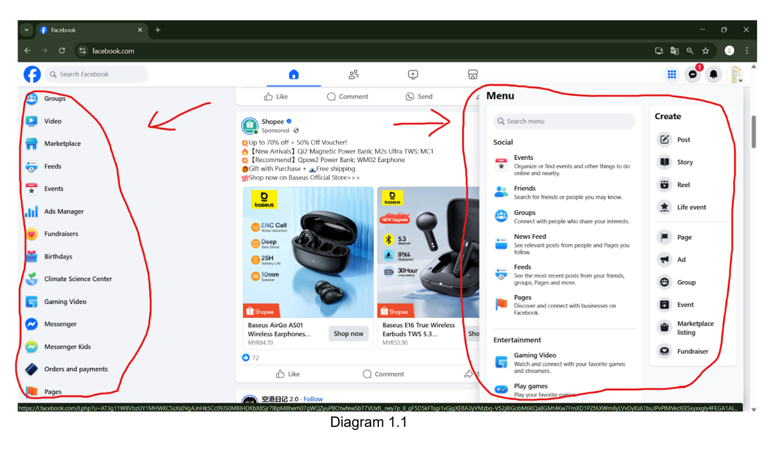
- The Facebook application produces interface chaos because numerous components including News Feed, Stories, Watch, Marketplace, Groups and multiple others compete against each other for users' focus. The numerous features along with busy sidebar notifications combine with various content types to create an interface that affects user experience negatively. The combination of promotional content and suggested ads creates barriers for users who want to maintain personal contact because their path to interaction becomes obstructed. The platform presents itself as an overload of features in a confusing center that attempts multiple functions simultaneously.
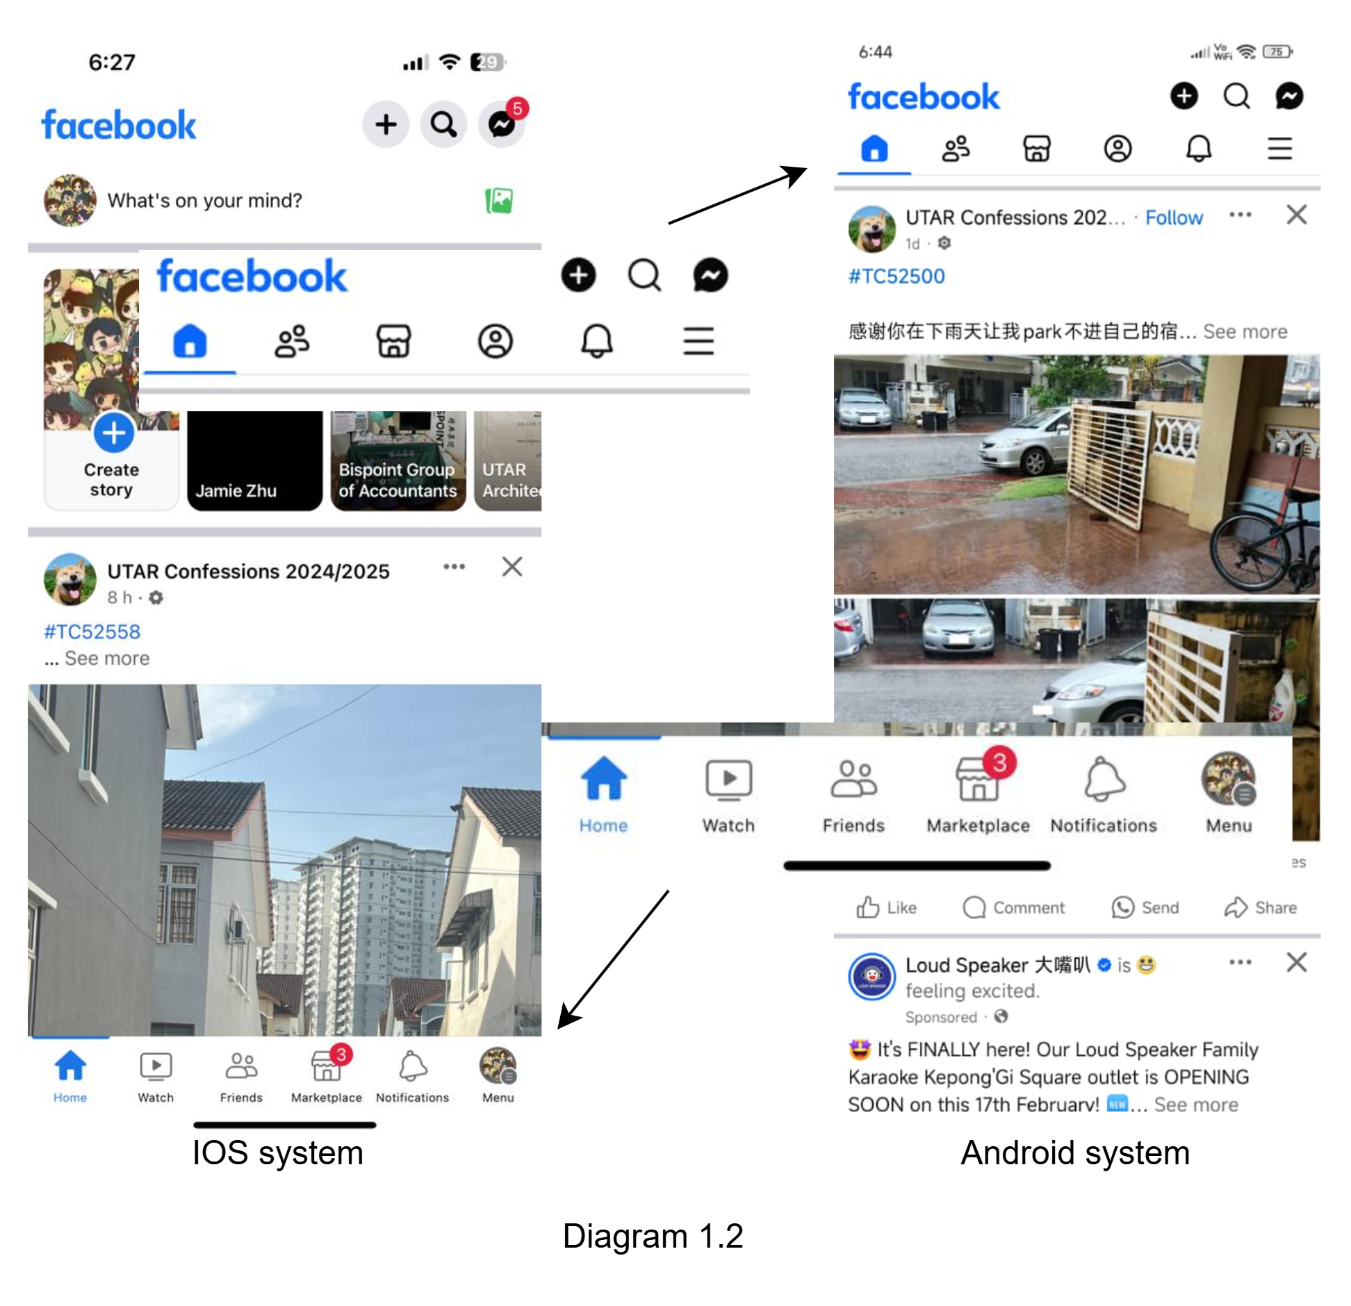

Impact
The overwhelming interface leads to frustration and confusion, making it difficult for users to find settings, manage privacy options, or navigate seamlessly between pages, groups, and the news feed. The steep learning curve especially affects new or less tech-savvy users, causing a frustrating experience as they struggle to adapt to frequent changes. The increased learning curve especially affects new or less tech-savvy users, causing a frustrating experience as they struggle to adapt to frequent changes. More user complaints, as many users express dissatisfaction with navigation difficulties, further burdening Facebook’s already limited support system.

Problem 2: Excessive Notifications and Distractions
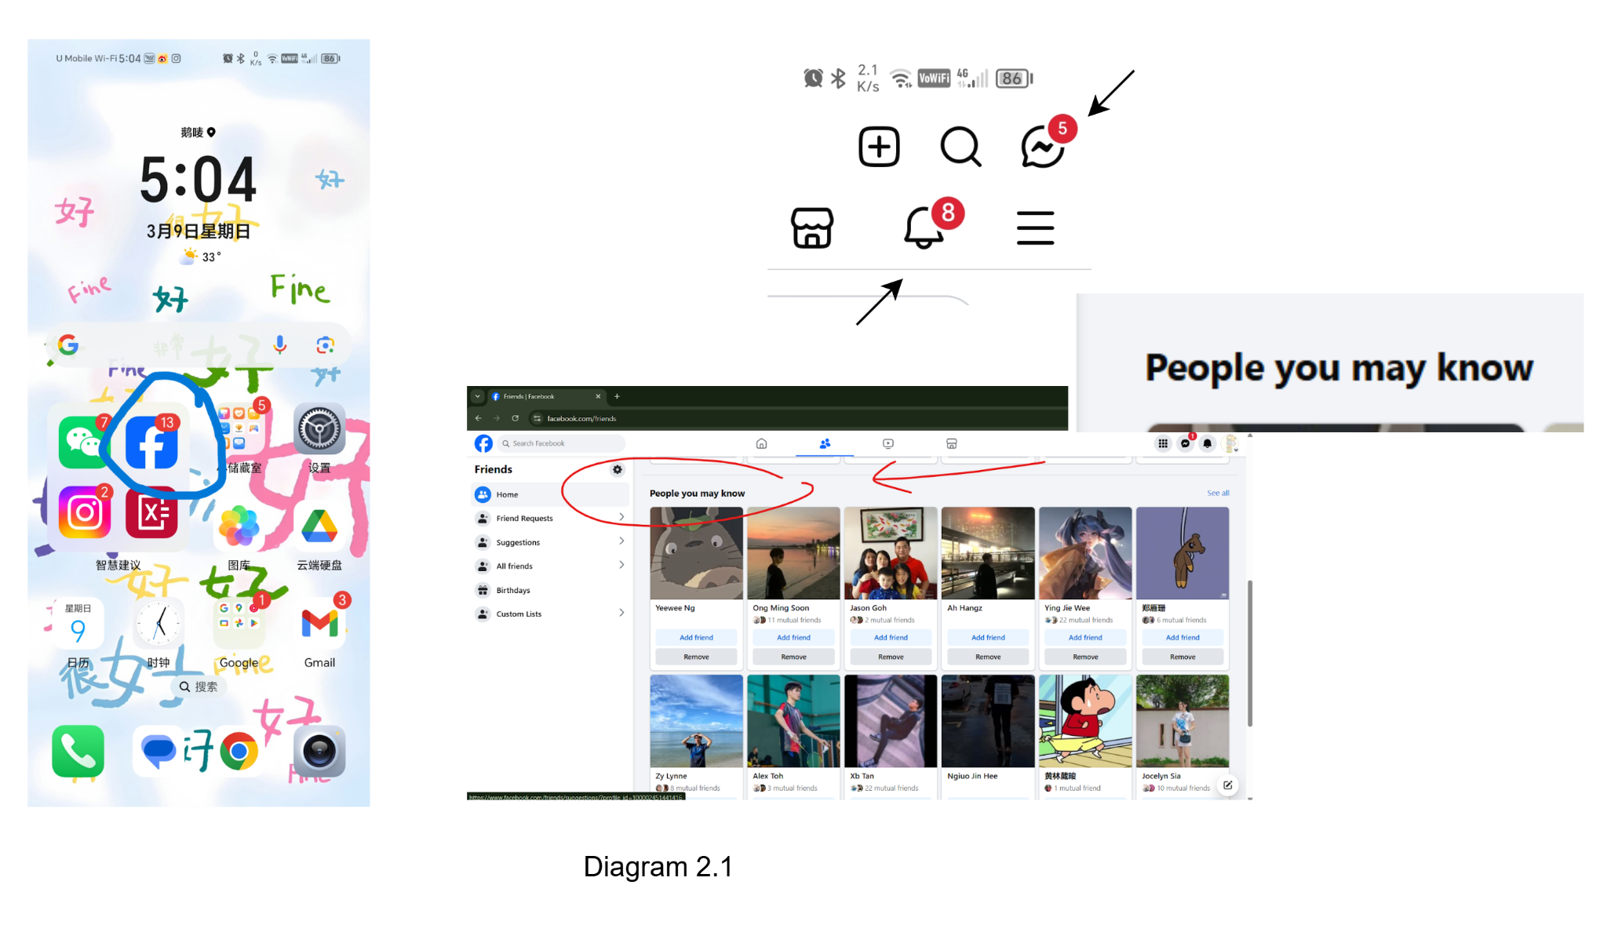
- Facebook generates frequent notifications including friend recommendations and unknown post updates subsequently distracts users toward notification fatigue. The platform becomes intensely intrusive when the red notification icon relentlessly wants users to pay attention. Users experience diminished satisfaction because excessive alerts from Facebook create annoying interruptions which break their concentration from useful interactions.

Impact
Constant alerts from Facebook disrupt focus and workflow, reducing productivity as users struggle to complete tasks efficiently. The frequent digital distractions from notifications and suggested content also lead to a decreased attention span, as users become conditioned to short, rapid interactions, making it harder to engage with long-form content or deep, meaningful work. Additionally, the persistent red notification icon an urgency and induces stress and anxiety, compelling users to check their updates obsessively. This contributes to a heightened fear of missing out (FOMO), where users feel pressured to stay constantly connected.

Problem 3: Ad Intrusiveness
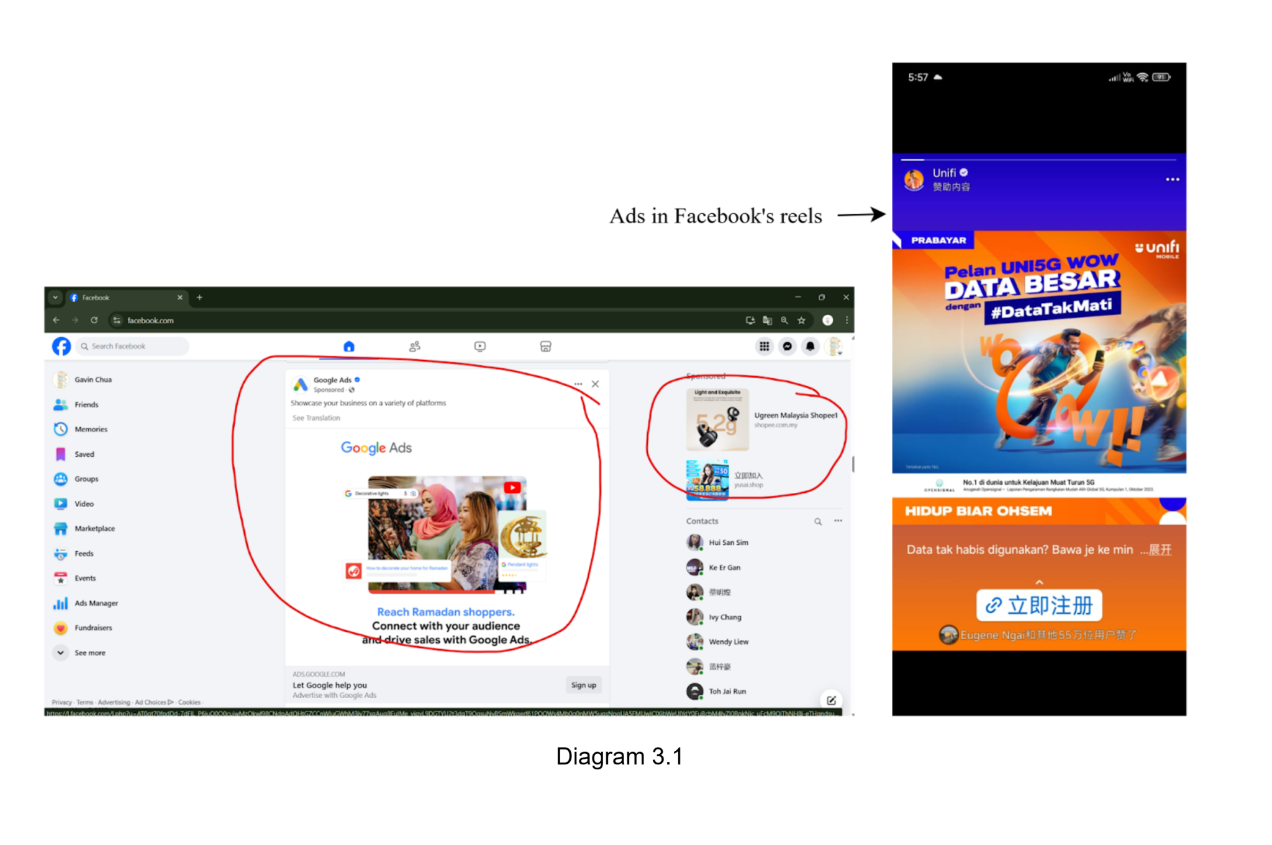

- Ads are often placed within the feed in a way that disrupts the user experience, making them feel intrusive and overwhelming. Additionally, the high frequency of ads can negatively impact the overall user experience, causing the platform to feel more like an advertising space rather than a social network.

Impact
User migration may occur as users shift to competing platforms like Instagram or TikTok, which offer a better balance between ads and content. Additionally, intrusive ads can disrupt the natural flow of content, degrading the user experience and making it harder for users to enjoy their time on social media.

Problem 4: Breaks Seamless Navigation (requiring users to download a separate Messenger app to chat)
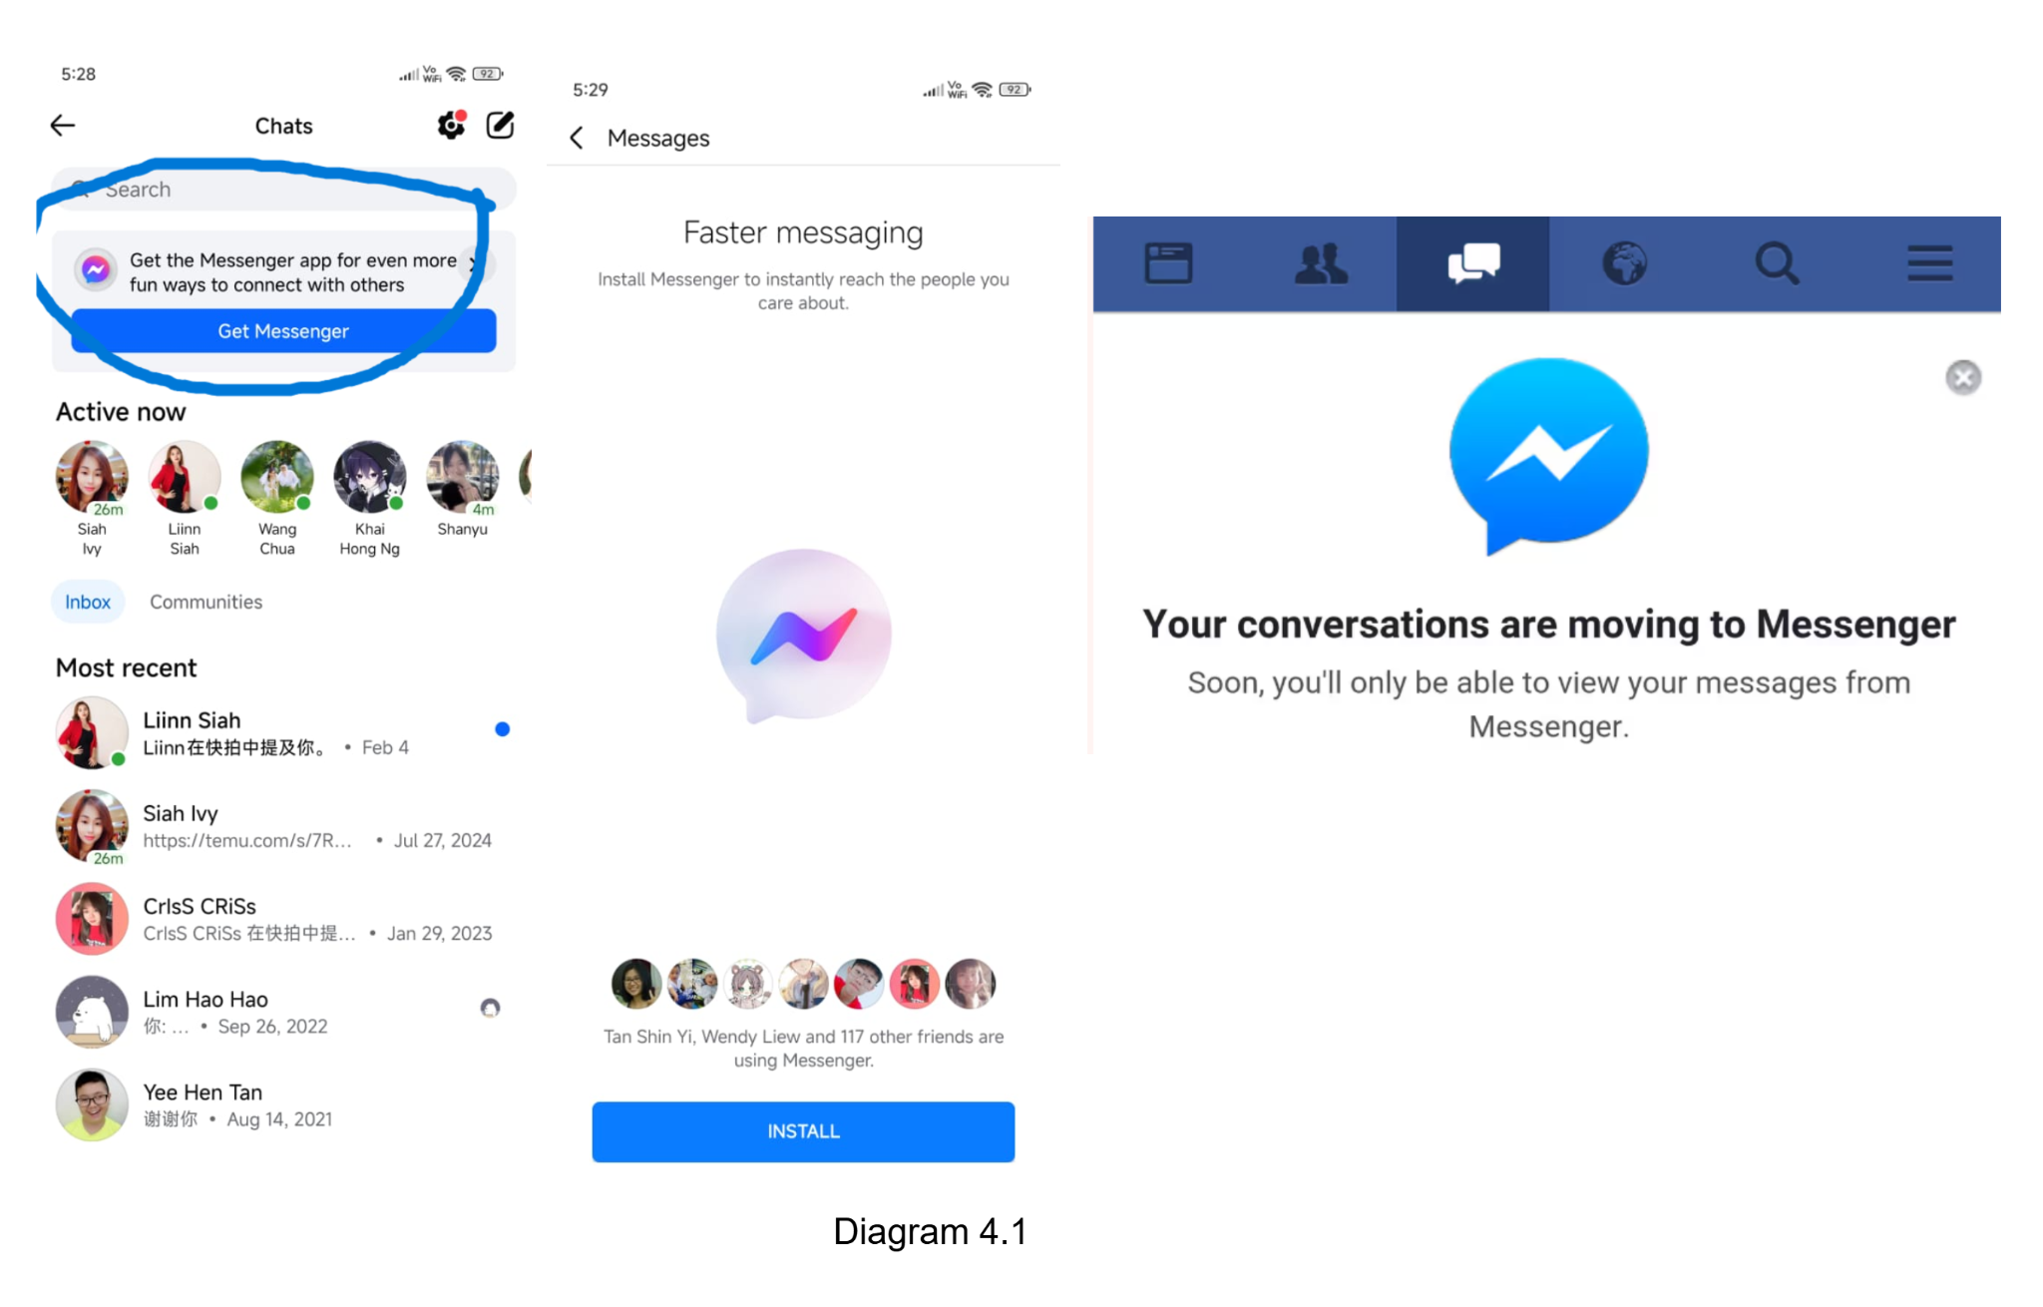
- Facebook and Messenger have separated into two independent apps. Two of them must exist together to ensure consistency and maximize effectiveness . Besides that, users need to download the messenger app for making communication on mobile in addition.
Impact
Managing conversations across two separate applications increased cognitive demands, particularly affecting users with cognitive impairments. It also required a separate app consuming additional device storage and resources, which could be a barrier for users with limited device capabilities.

Persona
Persona 1
User Persona: Ben
Age: 27
Occupation: Educator (Secondary School Teacher)
Background:
Ben has been a passionate educator for over a decade, specializing in STEM subjects. He enjoys integrating technology into his teaching to make learning more engaging and accessible. He often uses online platforms like Facebook Groups and Live Sessions to share resources, conduct discussions, and engage with students and fellow educators. Ben uses online platforms daily, primarily for professional and educational purposes. On weekdays, he checks Facebook briefly in the morning and afternoon for updates from educational groups . He also conducts Facebook Live sessions or uploads recorded lessons to support student learning.
Goals:
Ben aims to enhance student engagement through digital tools by leveraging interactive platforms that foster active participation and collaboration. He wants to create a more dynamic and immersive learning experience using Facebook Groups, Live Sessions, and other online resources. His goal is to ensure students remain motivated and interested in STEM subjects by integrating multimedia content, quizzes, and discussion forums. Additionally, he seeks digital tools that are easy to navigate, accessible to all students, and compatible with his teaching style, allowing him to deliver lessons effectively while tracking student progress.
Challenge:
Ben struggles with excessive notifications on Facebook, which disrupt his workflow and focus. While preparing lesson materials or grading assignments, he is frequently interrupted by irrelevant alerts, such as "people you may know" or updates on posts he hasn’t engaged with. These distractions make it difficult for him to efficiently manage his time and concentrate on creating meaningful educational content.
Technical Skill Level:
Ben is at an intermediate level in using digital tools for education. He is comfortable with Facebook Groups, Live Sessions, and posting content, allowing him to engage with students and fellow educators effectively. However, he needs guidance on advanced features such as Facebook ads, analytics, and automation tools to optimize his teaching methods.
Persona 2
User Persona: Gavin Chua
Age: 25
Occupation: Content Creator
Background:
Gavin started as a freelance writer but quickly transitioned into content creation, focusing on personal development, tech reviews, and digital productivity. He primarily uses Facebook, Instagram, and YouTube to reach his followers, but Facebook remains his main engagement platform due to its strong community-building features. Through videos, Reels, and live sessions, he educates and interacts with his audience.
Goals:
Gavin's goal of expanding his audience reach is crucial for his growth as a content creator. He wants to attract more followers across multiple platforms, particularly on YouTube and Instagram, while maintaining a strong presence on Facebook, where he already has high engagement. To achieve this, he must focus on increasing his visibility, improving discoverability, and encouraging audience interaction.
Challenges:
Gavin faces difficulties in maintaining consistent engagement on Facebook while keeping up with platform algorithm changes. Since Facebook prioritizes content that sparks discussions and interactions, Gavin must constantly adapt his content strategy to ensure his posts, videos, and live sessions reach his audience effectively. Additionally, competition from other creators and the platform’s ever-evolving features make it difficult to sustain visibility without investing significant time in analytics and community management.

Technical Skill Level:
Gavin has an intermediate to advanced technical skill level, proficient in content creation tools and social media management. His expertise includes video editing, digital marketing, and audience engagement strategies, particularly on Facebook. He is adept at producing high-quality videos, Reels, and live sessions, effectively educating and interacting with his audience on personal development, tech reviews, and digital productivity.

Persona 3
User Persona: Ivan
Age: 34
Occupation: Marketing Manager
Background:
Ivan, has seven years of experience in digital marketing and currently leads the marketing team at a tech company specializing in SaaS solutions. He started his career as a content marketer before transitioning into a leadership role, where he oversees brand strategy, digital campaigns, and audience engagement.Facebook remains one of his key platforms for customer acquisition, brand awareness, and lead generation. He actively uses Facebook Ads, Business Suite, and analytics tools to refine marketing strategies, boost engagement, and improve conversion rates.
Goal:
Ivan's goal is to increase brand visibility and enhance audience engagement through a combination of paid and organic content. He aims to leverage strategic digital marketing efforts to strengthen the company's presence, attract potential customers, and drive meaningful interactions across various online platforms.
Challenges:
Since customers regularly post negative reviews in Facebook comments, Ivan constantly faces the problem of handling negative feedback and public concerns. Improper handling of these concerns might harm the brand's reputation and sway potential buyers. Ivan must actively monitor and respond to feedback promptly, balancing professionalism with effective problem-solving. However, handling a large number of complaints can be overwhelming, especially when clients demand prompt replies.

Technical Skill Level:
Ivan is an expert in digital marketing, with a focus on SaaS-based tactics and Facebook marketing. He has a great deal of experience optimising campaigns, monitoring performance, and increasing interaction with Facebook Ads, Business Suite, and analytics tools. Ivan can develop and implement data-driven marketing strategies because he is also skilled in SEO, marketing automation, CRM integration, and conversion rate optimization.
Persona 4
User Persona: Lillian Chan
Age: 30
Occupation: Advertiser
Background:
Lilian works for a digital advertising agency as a performance marketer. Her area of expertise is developing, overseeing, and refining Facebook advertising campaigns for several customers in various sectors. She has more than six years of experience and is an expert in audience targeting, conversion monitoring, and paid social media marketing. She uses Facebook Ads Manager and Business Suite to manage campaigns, evaluate results, and modify plans in light of new information.
Goal:
Lilian aims to maximize ad performance, improve conversion rates, and optimize ad spend for his clients. She wants to create highly targeted campaigns that drive engagement, sales, and brand awareness while staying within budget constraints.
Challenges:
Lilian finds it difficult to maintain her advertising creatives interesting. Repetitive content eventually loses the audience's attention, which lowers engagement rates, click-through rates (CTR), and costs per conversion. Ad performance may suffer if viewers encounter the same ads too often since they may ignore or even hide them.
Technical Skill Level:
Lilian is an expert in Facebook advertising. She is proficient in Facebook Ads Manager, Business Suite, retargeting strategies, A/B testing, Pixel integration, audience segmentation, and performance analytics. He continuously refines his ad strategies using real-time data and automation tools to enhance results.

Task Analysis of Current Task
Send message on Facebook
To send a message with your families or friends on Facebook, start by opening the web browser or the Facebook app on your device. Then, enter your username (email/ phone number) and password. Click the “Login” button. After login. click on the messenger icon at the top right of Facebook. If you haven’t downloaded the Messenger app, it will show the message that prompts the user to get the app. Get the Messenger app from App Store or Google Play Store. Open the Messenger app and log in by using your Facebook account. You can choose to go back to Facebook or stay on Messenger. Then, click the person you want to chat with. Type your message and press “Send”.
Pain point: Users are required to download the Messenger app to ensure the communication function integrity.

Browsing content on Facebook
To browse content on Facebook, login to Facebook firstly. Open the web browser or the Facebook app on your device. Enter your username (email/ phone number) and password. Then, tap the “Login” button. After login to Facebook, you may see the advertisement at the side of the main page. Scrolling through the Facebook page. The news feed at the home page displays posts from families, friends, groups and followed pages. You may see some advertisements appear between the news feed and posts. When you want to watch the Facebook stories, click the stories on the top of the main page. View the stories that are posted by families or friends. The advertisements appear again between every few stories.

Pain point: The high frequency of ads has affected the user’s convenience when using the app usually. Users may find it harder to focus on meaningful interactions with friends and family, as ads dominate their attention and it is due to the ads placement.

Distractions on Facebook
To face distractions on Facebook, start by opening the Facebook app on your device and logging in with your username and password. Upon reaching the homepage, you are floods with distractions immediately with the glaring red notification icon, pop-up alerts, and constant badge counters all demanding your attention like experienced when notifications constantly pulled you away from studying, each alert hijacking your focus with manufactured urgency. If you attempt to watch stories at the top of the page, you will face additional interruptions from ads inserted between every few stories. Sometimes quiet mode helped, but when his phone restarted, all the notifications came back at once.
Pain point: Excessive notifications and distractions on Facebook make it difficult to stay focused and manage time effectively.
Shopping on Facebook
Start by accessing the facebook website or application through your account. Moving to the right or above portion of the post displays the Marketplace icon. The Marketplace homepage presents an overwhelming visual presentation because it combines product listings with ads alongside suggested items and sponsored posts. On the post there is a function icon located at the top (Android). The marketplace becomes accessible through your click before showing you different products of the day. (IOS) The difference with the Android version, the function icon under the post. After selecting the marketplace icon you will find the sell function on top of the upper section. Navigating through seller posts enables the tool to access published content as well as review and history performance. Users have two options to search products: they can use the search bar or browse through available items. Application filters with price along with location and category allow users to narrow down their search results. View seller product details while also reaching out to the seller by clicking the chosen product. You should either discuss the price with the seller or verify existing stock availability.
Pain Point: Differences in menu placement, navigation structure, and feature availability make it difficult for users to locate settings or perform common actions seamlessly. This inconsistency frustrates users, reduces efficiency, and makes adapting to a new device more challenging, especially for less tech-savvy individuals.

Scenario of Current Task
Scenario 1
Sarah wants to message her cousin, Lisa on Facebook. She hasn’t used Facebook in a while and is unaware of the requirement to use the Messenger app for chatting. Sarah opens the Facebook app on her phone. Then, she goes to the search bar, types “Lisa” and taps her profile. She clicks the “Message” button, expecting to chat directly. When she is opening a chat window, Facebook shows a message “To continue chatting, download the Messenger app.”. There’s a prompt with a “Get Messenger” button leading to the app store. She needs to download the app in addition. So, she goes to the App Store/Google Play Store to download the app but she encounters the issue that her phone storage is not enough. She needs to delete some things to clear her storage in order to download Messenger.

Scenario 2
Alex opens Facebook to catch up on updates from friends and pages the following. When he logged into Facebook, he saw that there was some advertisement at the side of the main page.
At first he didn't care and then he continued scrolling through the Facebook page. The news feed at the home page displays posts from families, friends, groups and followed pages. He started seeing more ads appear between the news feed and posts. After that, he goes through the Facebook stories. He wants to see the stories that are posted by his family and friends. But the advertisements still appear again between every few stories. These ads let him not enjoy his social media experience properly.

Scenario 3
Cyrus was determined to study but Facebook constantly interrupted him like send a notification to his phone. At first, he tried to ignore them, but his friends kept messaging him, pulling his attention away from his work. So he try to disabling notifications, unfollowing distracting friends, setting screen time limits, but it nothing work. Even when he installed Freedom to block the app completely, he found ways around it, telling himself he’d just check for "one minute," only to lose hours. Quiet Mode helped sometimes, but glitches forced him to restart his phone, reopening the door to temptation. When it powered back on, his notification center was flooded with Facebook alerts that had piled up while his device was off.

Scenario 4
Jason begins his Facebook session through application or website access to his account. Users can locate Marketplace through its position on the right side of Desktop, but the placement differs between Android and iOS system, where it shows above content for Android but appears below posts for iOS. After selecting the Marketplace icon, Jason encounters a disorganized homepage that contains product ads, suggested items, and sponsored content, making his search difficult due to lack of clarity. The search query of "second-hand laptop" within the bar produces results containing laptop accessories and chargers that do not match his needed item. His search becomes more targeted after he activates price, location, and brand restrictions. After finding a suitable listing, he clicks through it to see the seller information, product descriptions, and visual content. He reaches out to the seller through Messenger to check the laptop condition and bargain for price before confirming availability to schedule a secure meeting for the transaction.

Environment Analysis
Physical environment
The Facebook application allows the user to access by using mobile phone, tablet, personal computer and desktop. Users can choose their favorite device to use this app and it supports IOS and Android systems. Most users almost use this application every day, no matter when and where. For example, during leisure time after working. They use it to get the latest real-time intelligence, see the stories that are posted by family or friends. Besides, users can also use it to buy the product through the marketplace, create posts or reels, communicate with family and friends, etc. There were some interruptions such as unnecessary notifications frequently, inconsistency of the design in different systems, ads intrusiveness and breaks seamless navigation.

Social environment
Facebook’s social environment is a place where users interact, share content, and connect. Each user has a profile to share updates, and they can make friends to follow each other's posts. The News Feed shows updates from friends, groups, and pages they follow. Users can join groups with shared interests, message each other, and organize events. Facebook also lets businesses and celebrities create pages to connect with followers. The platform uses algorithms to show users content based on their interests, and privacy settings let users control who sees their posts. Overall, Facebook is a space for personal, community, and public interactions, while also facing issues like privacy and misinformation.

Technical environment
The technical environment of Facebook includes the technology and systems that make the platform work. Facebook uses large server farms and scalable databases to store and process user data, making sure the platform works well and is always available. It is built using programming languages like PHP for the core and React for the front end. Facebook uses algorithms and machine learning to personalize content, such as suggesting friends and showing posts in the News Feed. A Content Delivery Network (CDN) helps deliver images and videos quickly worldwide. Facebook also offers Application Programming Interface (APIs) for third-party apps to connect with its services. Security is important, with features like encryption and two-factor authentication to protect user data. Facebook uses cloud computing to handle large amounts of data and Artificial Intelligence (AI) to improve features like translation and content moderation. Overall, Facebook's technical environment combines hardware, software, and advanced technology to support its global users.

HTA Analysis
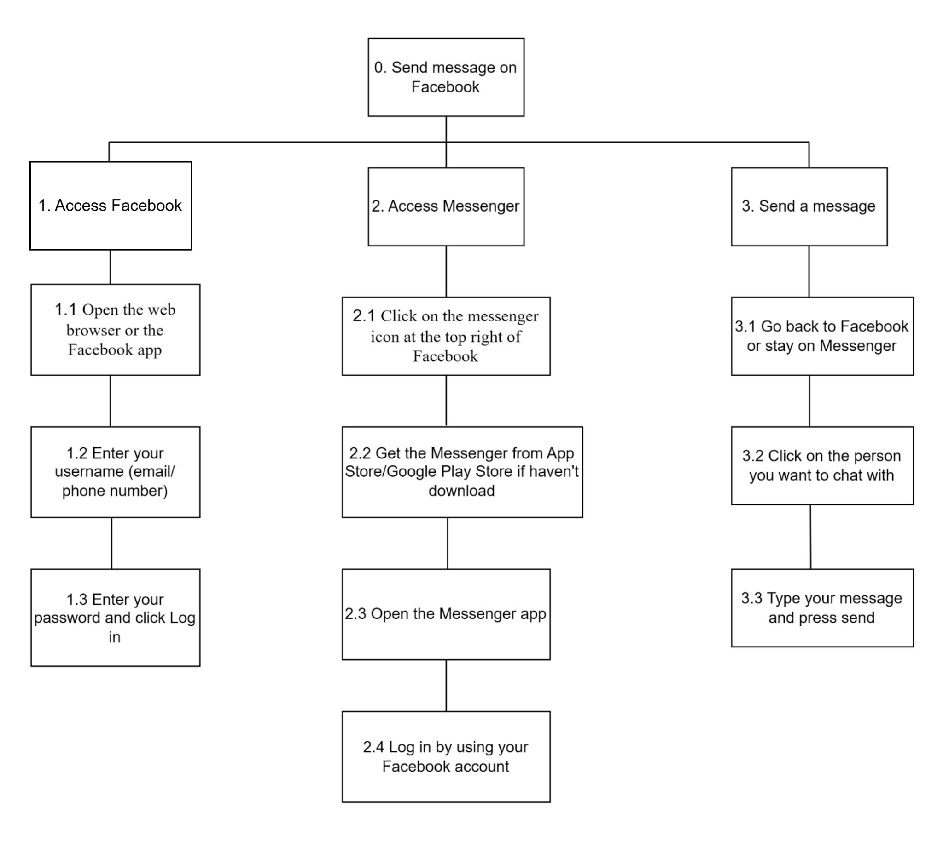
Diagram 5.1 Send message on Facebook
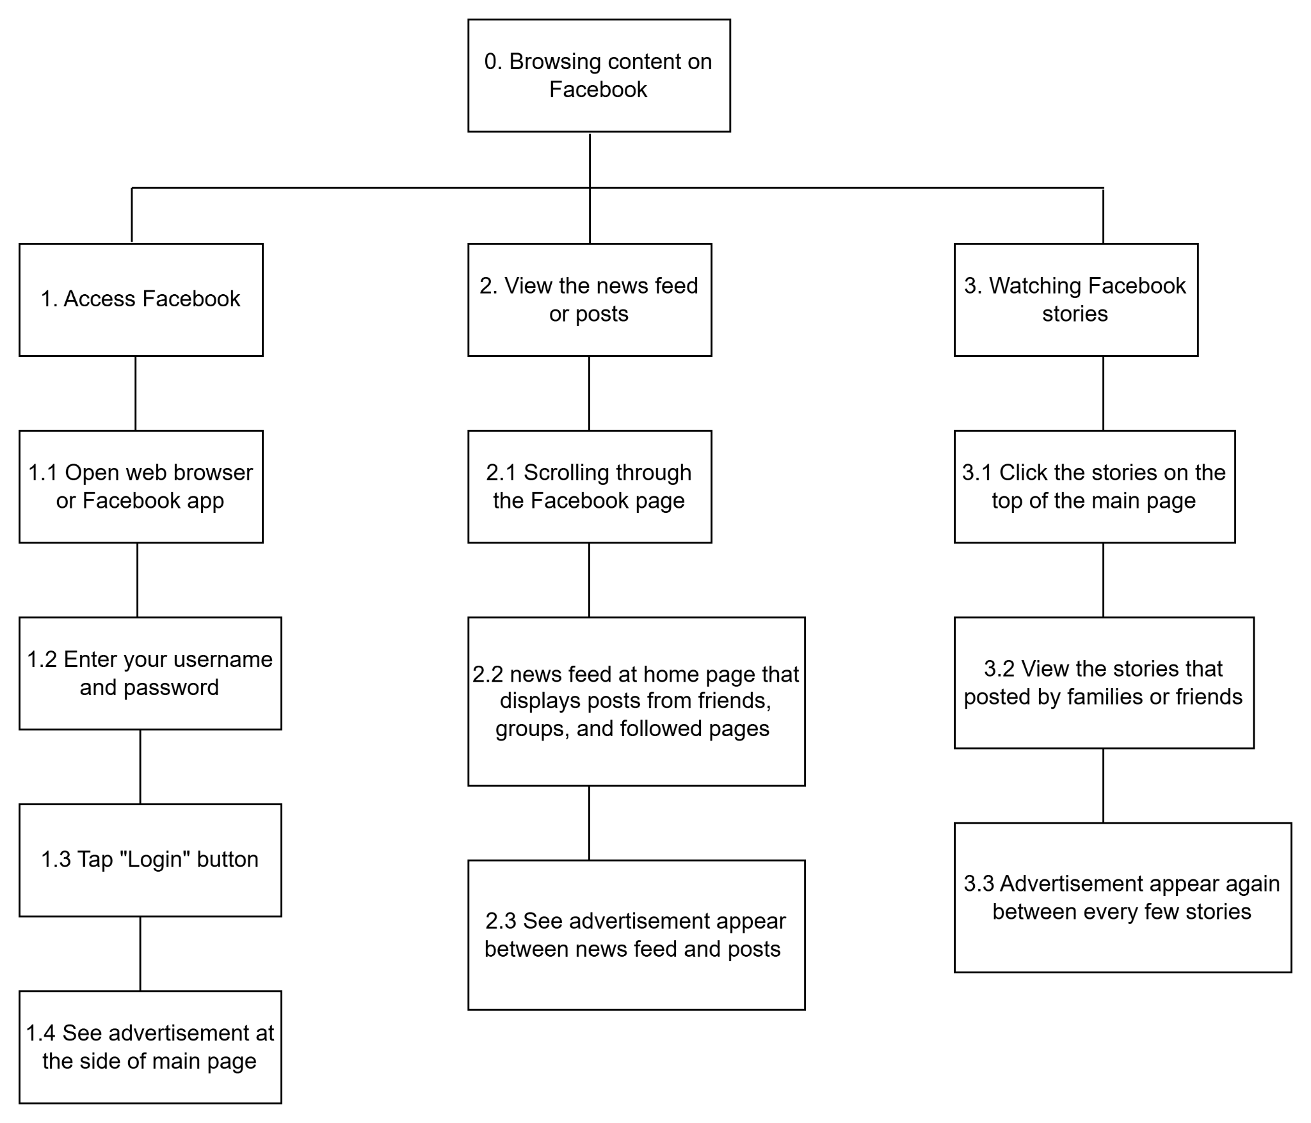
Diagram 5.2 Browsing content on Facebook
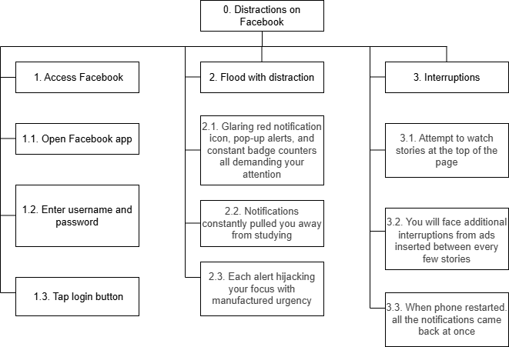
Diagram 5.3 Distractions on Facebook

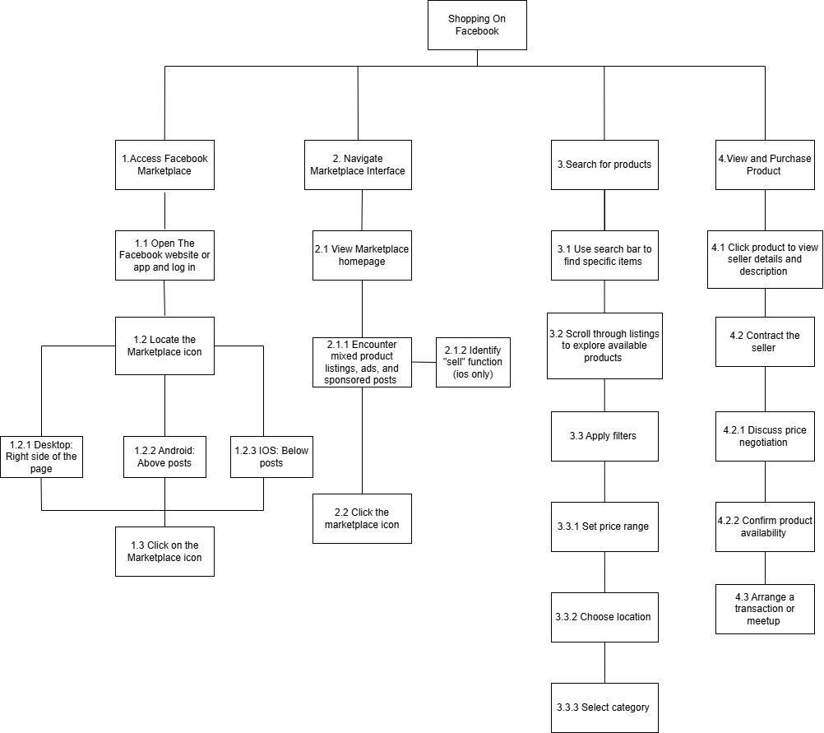
Diagram 5.4 Shopping on Facebook

References
Problem 1:
Sim, M. (2021, December 10). Facebook: the 4-hour UX redesign challenge — a UX case study. Medium.
https://uxdesign.cc/facebook-redesign-the-4-hour-ux-design-challenge-801cc9a5b195
Problem 2:
Katelaris, E. (2025, March 7). If you do this, you’re addicted to your phone. News.
https://www.news.com.au/lifestyle/health/mental-health/common-habit-that-proves-youre-addicted-to-your-phone/news-story/b57fc4e0bb74d3105e6b8d53ffd5581f?
Fox News. (2024d, December 15). What is brain rot? The science behind what obsessive scrolling does to our brains. New York Post.
https://nypost.com/2024/12/15/health/what-is-brain-rot-the-science-behind-what-obsessive-scrolling-does-to-our-brains/?
News.com.au. (2025, March 7). You’re addicted to your phone if you repeat this common habit, study reveals. New York Post.
https://nypost.com/2025/03/07/health/common-habit-that-proves-youre-addicted-to-your-phone/?
Problem 4:
Fiveable. (n.d.). Cognitive load and language processing. Fiveable Library. https://library.fiveable.me/psychology-language/unit-9/cognitive-load-language-processing/study-guide/2mXGkycjLQFxKImC

